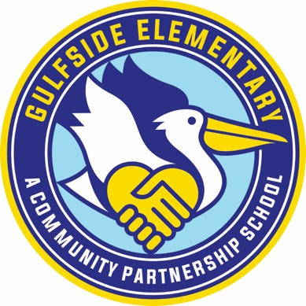
Kindergarten

1- box of gallon size Ziploc bags
1- box of 1quart size Ziploc bags
2- packs of Crayola Crayons
2- packs of Jumbo glue sticks
1- pair of Fiskars Blunt Scissors
1- Plastic Standard Pencil Box
2- Boxes of Tissues
1- Standard Size Backpack (No Wheels)
1- pkg Black thick Regular Expo Dry Erase Markers
1- pkg Black thin Expo Dry erase markers
2- roll paper towels
2- pack of baby wipes
1- packs of copy paper
1- box of Magic erasers
- Pair of corded headphones (please label with student’s name, no ear buds)

Wishlist:
1 pack of white card stock
Monthly Snacks for the class for the week 18-24 students

* Please do not label your child’s name on any items except the headphones

