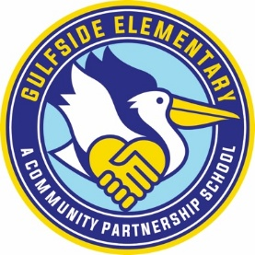
First Grade
1 - pair of corded headphones (please label your student's name)
2 - boxes of pencils
2 - boxes of 24-pack of crayons
2 - packs of black dry erase markers
2- pcs black primary composition
1 - pack of colored pencils
1- pack of glue sticks
1 - package of gallon zip-lock baggies
1 - package of quart zip-lock baggies
1- package of sandwich zip-lock baggies
1 - box of tissues
1 – package of baby wipes
1 - package of plain band-aids (no characters on them)
Clorox disinfecting wipes

Wishlist:
Snacks for class *no peanut items*
(Ex. - Goldfish, pretzels, fruit snacks, cereal, etc.)
Paper Plates
Plastic Cups

* Please do not label your child’s name on any items except the headphones

