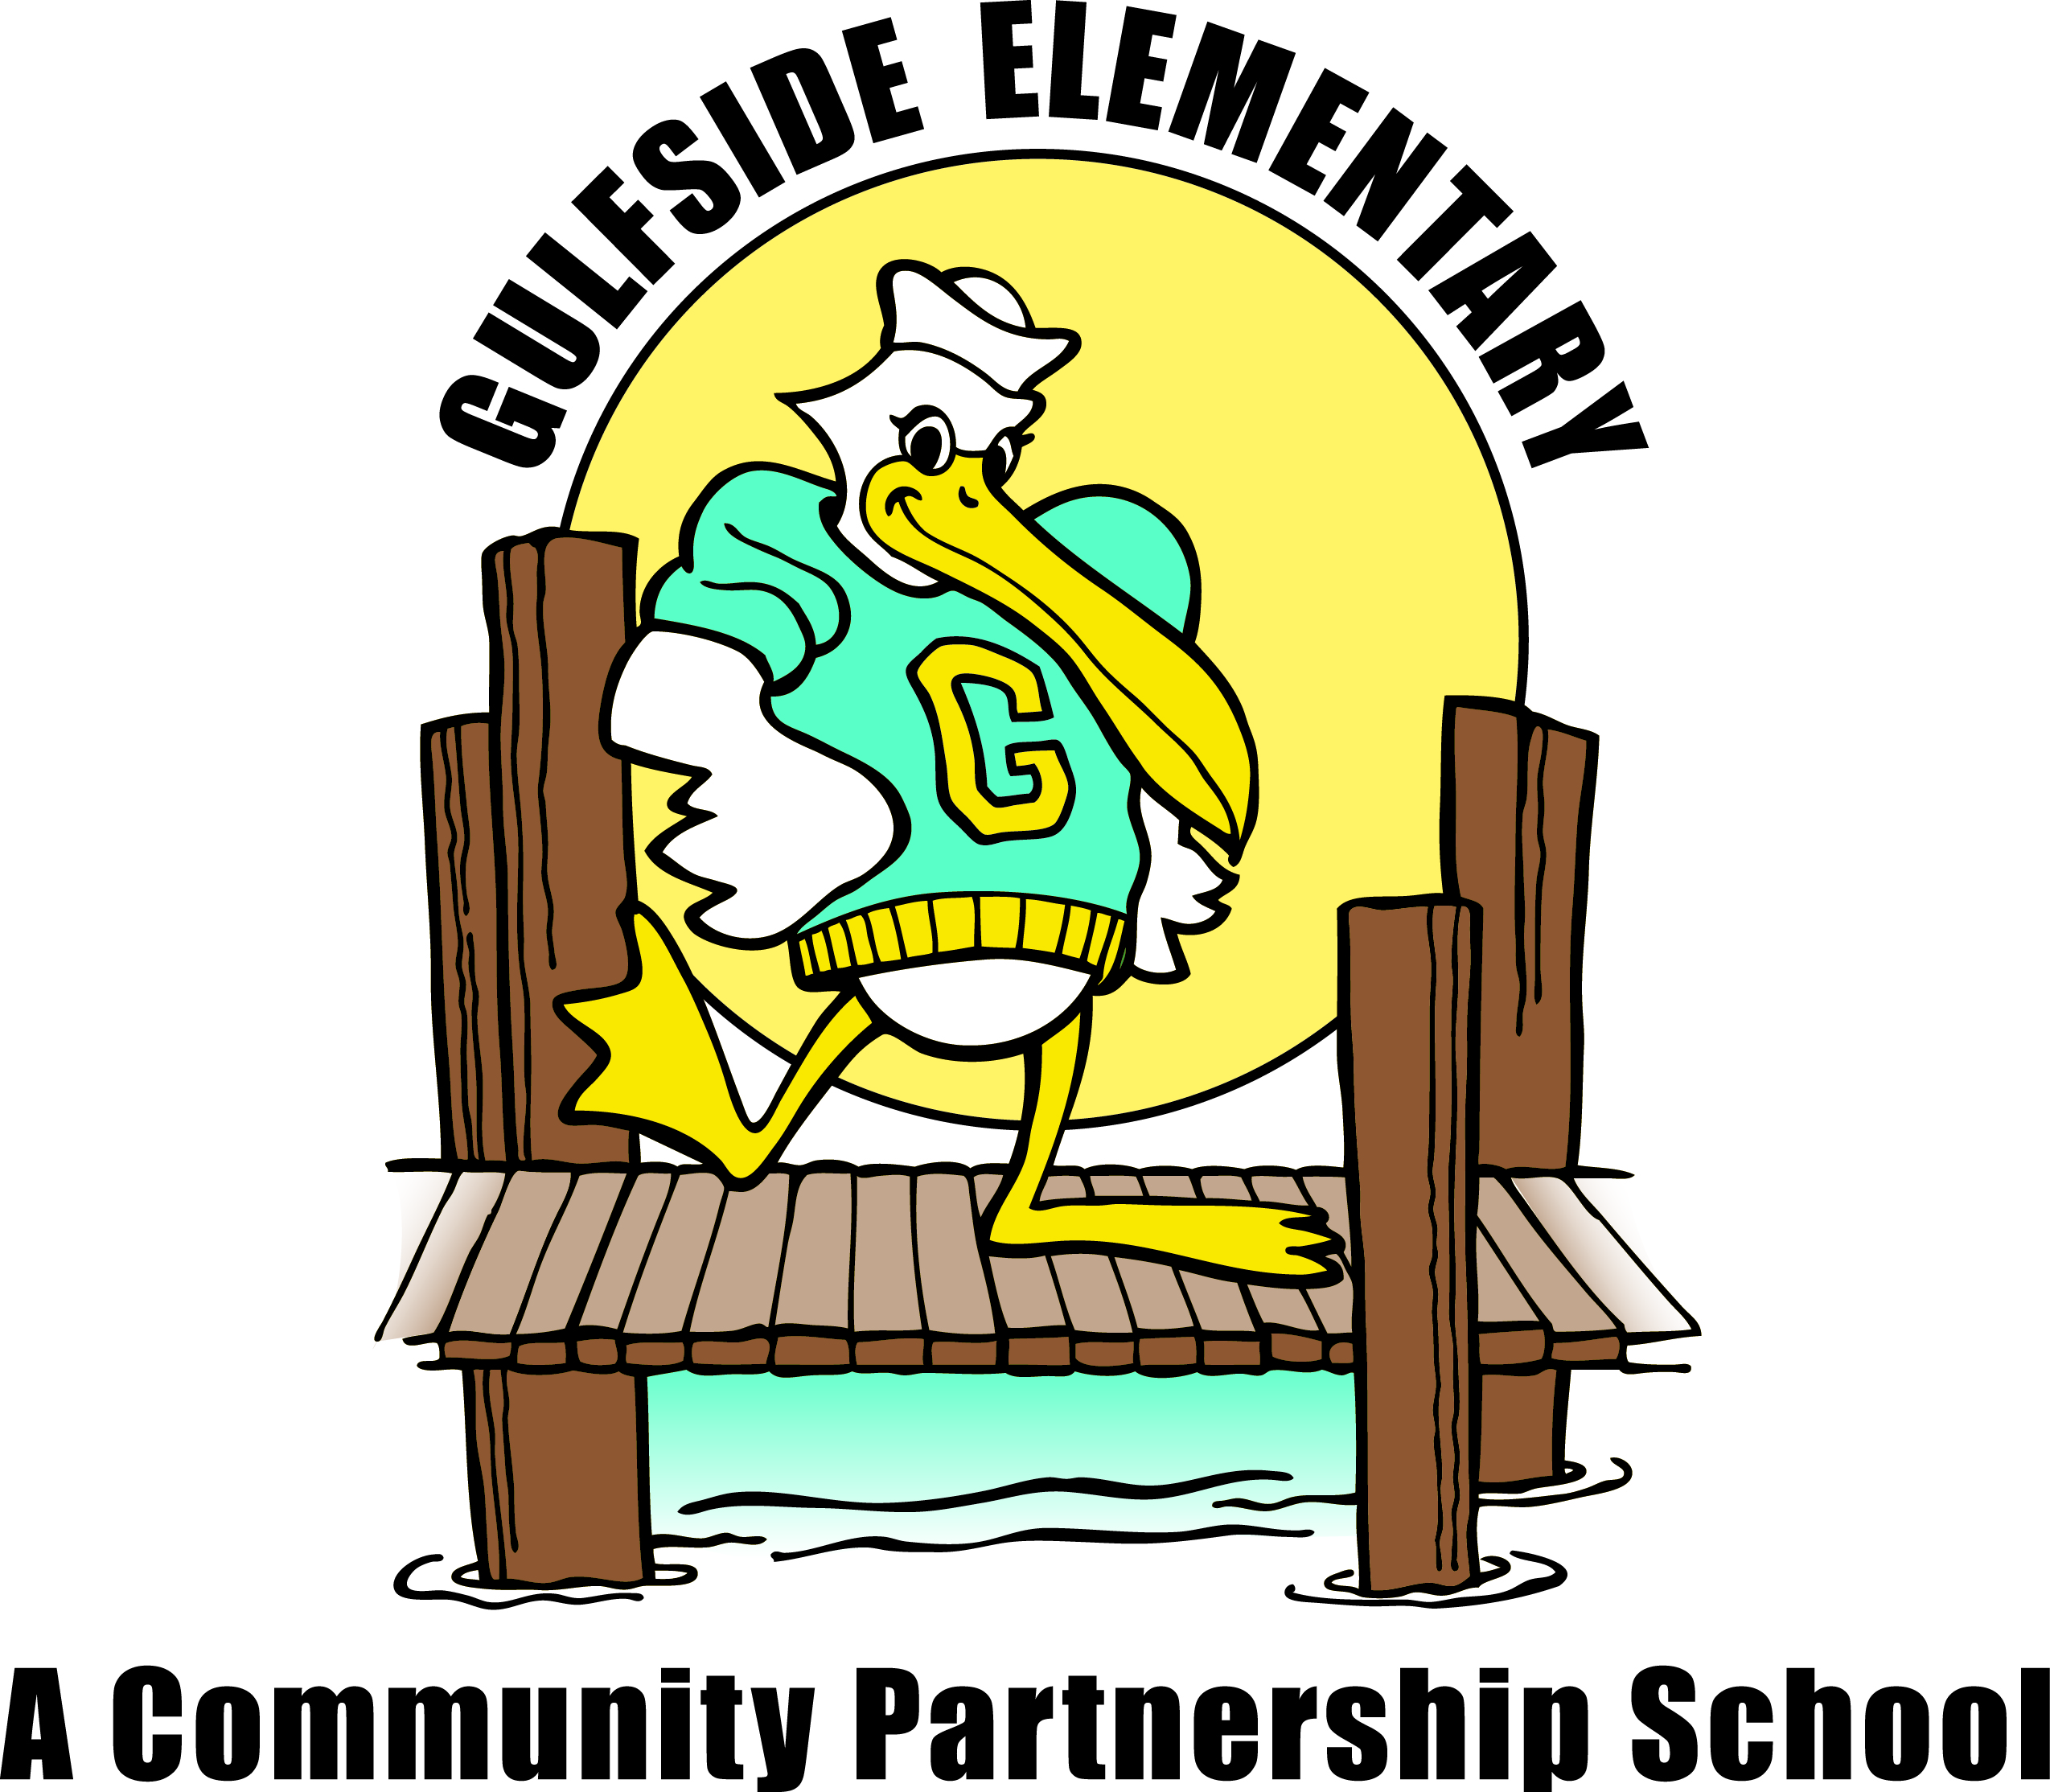
Gulfside Elementary
Family/School Compact 2021-2022

The education of our children is a partnership between home and school. As partners, we will have constant communication in the form of Facebook, newsletters, parent/teacher conferences, phone calls, planners and the school website. Some documents are translated into Spanish when possible. Family members are encouraged to participate in school events and to be a part of our volunteer program. By working together, we will make a difference in the lives of our children.

*As a FAMILY, we will:
Be sure our child participates in school for the entire day to maximize instructional time.
Communicate regularly and request help when needed.
Prepare our child for school by making sure he/she is well rested and nourished.
Support the school in developing positive behaviors.
Send my child to school every day on time and limit appointments during the school day.
Encourage completion of all homework assignments, to include 30 minutes of reading nightly.
“My preferred method of contact: Phone: ______________Text: _____________ Email:_________________”
A goal for my child this year:
______________________________________________________________________
*As a STUDENT, I will:
Come to school with a good attitude and be ready to learn.
Be safe, respectful, and responsible by following school and bus (if applicable) expectations.
Ask for help when I need it.
Always do my best work and never give up when something is challenging.
A goal for me this year:
______________________________________________________________________
*As a TEACHER, I will:
Create a partnership with your family by meeting your child's individual needs and
communicating progress, concerns and celebrations.
Provide a safe and supportive learning environment.
Offer a variety of times for conferences/meetings.
Additional teacher input:
______________________________________________________________________
I have received a copy of the District School Board of Pasco County tri-fold “Parent Engagement Matters!” explaining the goals of Title I schools.

Parent/Guardian _______________________________________________ Date____________
Student ______________________________________________________Date____________
Teacher _________________________________ ____________________Date_____________
This compact is an agreement to promote a partnership between the
home and school, which meet the requirements of Title 1.

