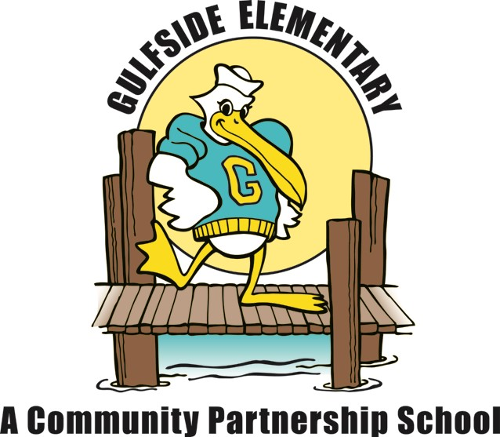
Gulfside Elementary
Kindergarten Supply List
2022 – 2023

Essential Items:
- 1 box of snack sized Ziploc bags
- 10 pencils
- 2 boxes of 24 Crayola Crayons
- 1 pair of Fiskars Blunt Scissors
- 1 plastic standard pencil box
- 1 three prong plastic folder with pockets
- 1 box of tissues
- 1 pack of 100 count index cards
- 1 standard size backpack (no wheels)
- 1 pack of regular black dry erase markers
- 1 roll of paper towels
- 1 pack of baby wipes
- 2 packs of copy paper
- 1 pair of wired headphones, in a ziplock bag labeled with student name, (Please no earbuds, used DAILY, will need to be replaced by parent if broken)
For Special Project
- 1 plain white t-shirt - one size bigger than your child currently wears

Note: Please do not write your child’s name on items, unless noted, as they are a shared part of our “Classroom Community of Supplies.”

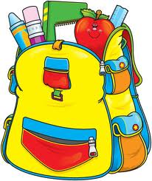

Wishlist

Snacks for the class for the week 18-20 students

