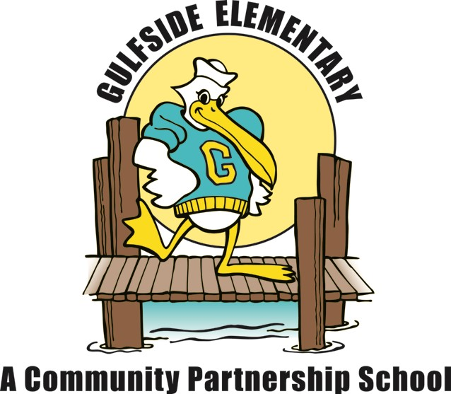
Gulfside Elementary
3rd Grade School Supply List
2022 – 2023

Essential Items:
- 24 #2 pencils
  - Preferred: Dixon Ticonderoga (these sharpen the best and the lead does not break)
- 2 boxes of Crayola 24 count crayons
- 1 pack of 12 Crayola colored pencils
- 8 glue sticks
- 1 pack of 3 pentel white erasers
- 1 hard plastic pencil box labeled with student name
- 3 composition notebooks, wide ruled, no special design covers please
- 4 plastic 3 prong folders with pockets (assorted colors are ok)
- 1 pair of wired headphones, in a ziplock bag labeled with student name
(Please no earbuds, used DAILY, will need to be replaced by parent if broken)
- 1 pack of large index cards

Note: Please do not write your child’s name on items, unless noted, as they are a shared part of our “Classroom Community of Supplies.”

Last Name Begins with A-M | Last Name Begins with N-Z
- 2 Packages disinfecting wipes  - 1 box tissues | - 1 container of hand sanitizer  - Ream of copy paper
Wish list Items for Classroom Use

Please: NO personal pencil sharpeners

