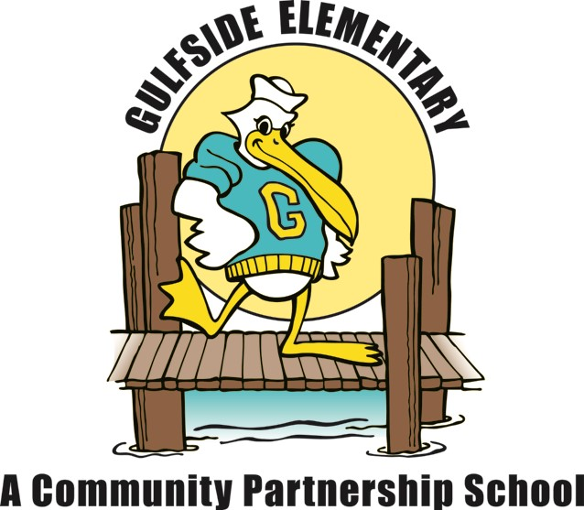
Gulfside Elementary
1st Grade School Supply List
2022 – 2023

Essential Items:
- 2 boxes of #2 pencils
  - Preferred: Dixon Ticonderoga (these sharpen the best and the lead does not break)
- 1 pack of black dry erase markers
- 2 boxes of 24 count Crayola Crayons
- 1 box of tissues
- 1 supply/pencil box of student choice (labeled with name)
- 1 ream of copy paper (white or colored)
- 1 pack of disinfectant wipes
- 1 pack of baby wipes

For Special Project
- 1 plain white t-shirt – one size bigger than your child currently wears

Note: Please do not write your child’s name on items, unless noted, as they are a shared part of our “classroom community of supplies.”

