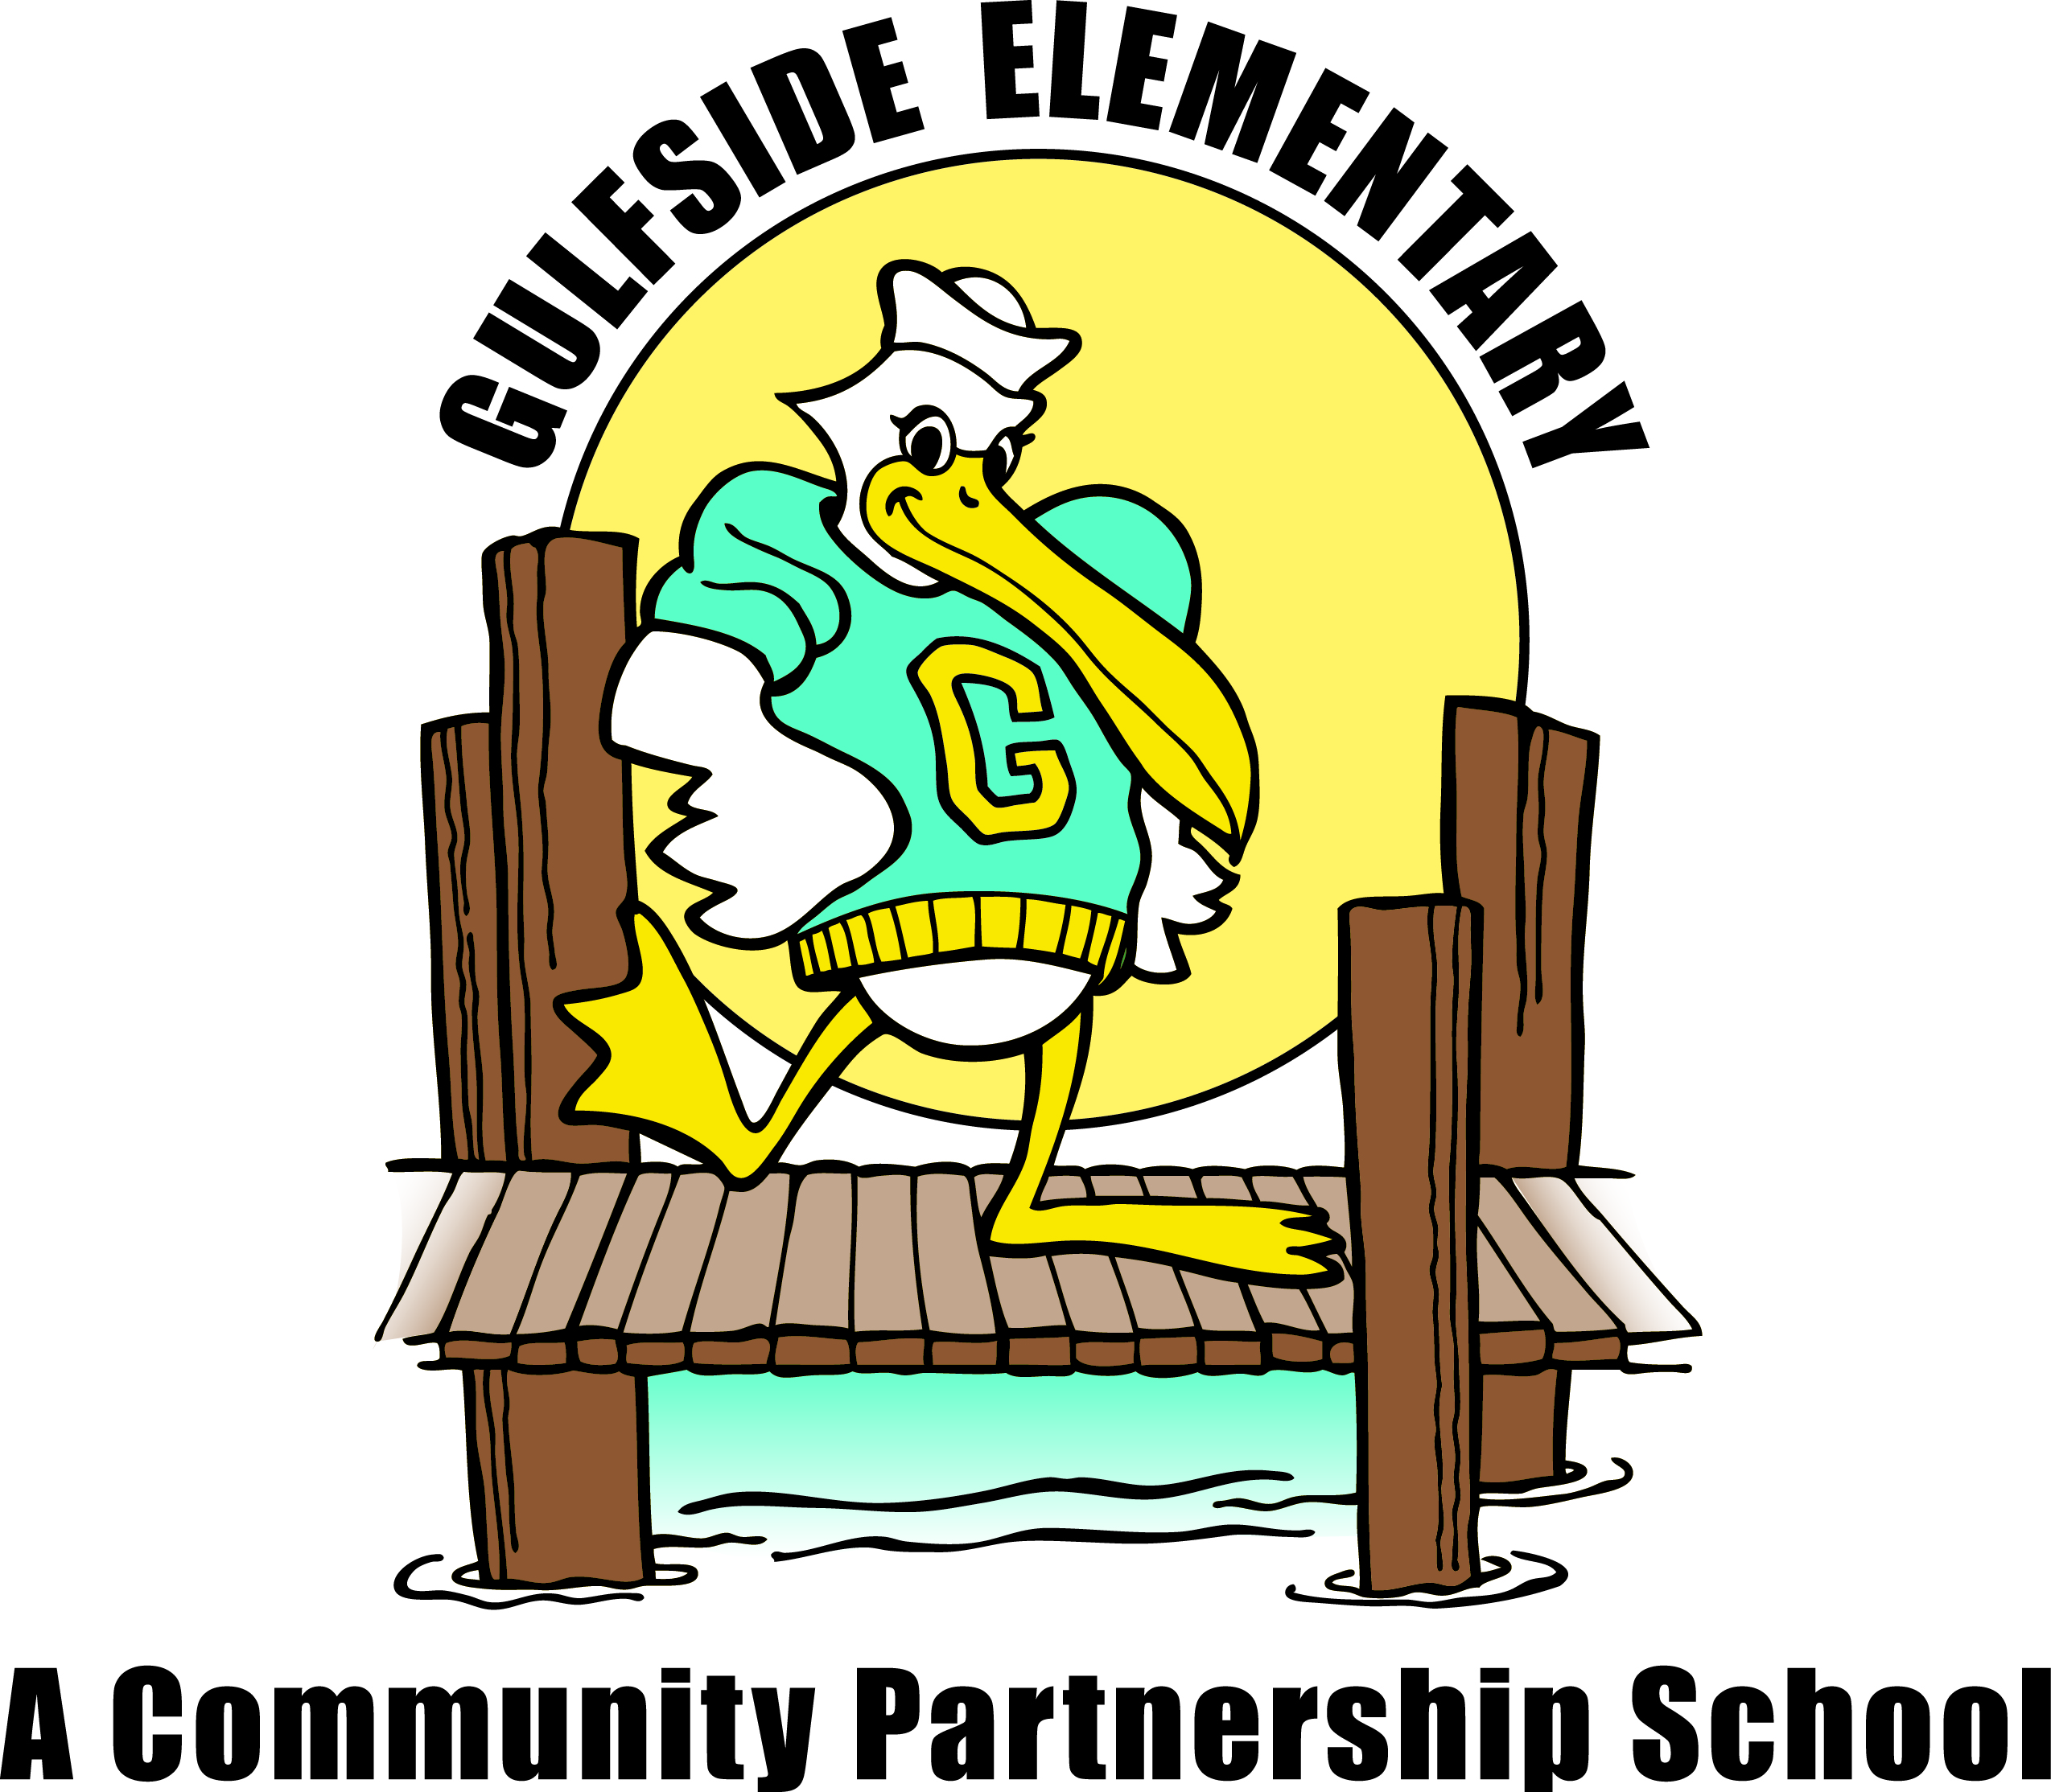
Pelican
Press

Jodi Legg, Asst. Principal
jlegg@pasco.k12.fl.us
Gulfside
Elementary

Clara Craig, Principal
ccraig@pasco.k12.fl.us
March 2, 2021 gses.pasco.k12.fl.us

Family Engagement
Families can partner with Gulfside by attending virtual and on campus school events, supporting classroom activities, becoming a Pelican Partner, joining PTO, SAC and Volunteering.
Mark Your Calendar

March
3/3 Early Release Day 2:08pm
3/12 End of 3rd Quarter
3/15-3/19 Spring Break
3/22 No School Teacher Planning Day
3/24 School Advisory Council
Zoom 2:30pm
April
4/2 No School
4/7 Early Release Day 2:08pm

May
5/26 Last Day of School for Students
5/27 Summer Break Begins

Florida State Assessments begin April 5th and end May 26th for all students in Grade 3, 4 and 5. More information will be sent home soon.

Feeding Tampa Bay Food Box Pick Up
Each Wednesday from 4:30 to 5:00pm, in the car loop, families and community members may pick up food boxes in our car loop. Please register online on our School or Hub Facebook pages, or call Mary Peralta at 727-774-6050 for more information. Thank you!

Staff Shout Out
Has a staff member at Gulfside Elementary gone above and beyond for you, your child, or family? If so, please take a moment and tell us so we can recognize them for their dedication. You can send an email to Dawn Ballister: dballist@pasco.k12.fl.us. We will share your moment with students, family and staff in the next newsletter.
Principal’s Message
Dear Gulfside Families,
As we move into March, let’s keep the momentum going to have every child read daily and every night! Your child should be able to select a media book at their IRLA reading level, identify their reading goal, and practice reading and writing using their new power words. All students are encouraged to take AR quizzes online when they finish reading their books or when a book is read to them by a teacher, friend or family member.
Thank you to all of our families for making sure students are in attendance on the school campus or online,
and engaged in learning each day! All of our online students need to have their computer cameras on during online instructional time. Please be sure to reach out to your child’s teacher if you would like to discuss your child’s progress and learning goals.
Please be sure to check the important dates and information listed in this newsletter. We are always looking for ways to better serve our students and families, so contact us with your suggestions/feedback.
I am very thankful for all of my Gulfside families as we work together to make a safe, caring, positive difference in our school community and for every child, every day!

Have a wonderful and safe Spring Break,
Ms. Craig

Continued Safety Protocol For Semester 2:
Masks must be worn by our staff and students the entire school day and on the bus each day. Please encourage your child to let their teacher know if they need to change their mask or if they need a new mask at any time. Our students do receive a mask break at recess, lunch and PE while making sure to social distance from their peers. Students may also wear a face shield instead of a mask if you wish. Please reach out to us anytime if you have any questions, suggestions or concerns.

February Citizens of the Month Congratulations: Kaidem Glaiber, Hailey Capabianco, Joseph Torres, Losanda Malak, Naylin Lovett, Melanie Newton, Yashwant Deen, Dylan Anding, Jordan De Leon, Isabella Watson, Robert Cruz Mendoza, Imani Ferron, Savanna Stanley, Autumn Williams, Jeremiah Davis, Lachlan Osores, Danica Munitz, Eduardo Caballero, Tevaughn Barnett, Aracely Mayedo, Zalen Rivera, Christopher Burch, Mikayla Earley, Tatiana Turner, Hailey Schmidt-Foltz, Ashley Humiston, Bryan Pineda, Clinton Seeders, Andrew Garcia-Ferrer, Joel Diaz
FREE & REDUCED LUNCH APPLICATION
Please keep your Free and Reduced Lunch status up to date as all approvals are for one school year only. All families must apply now to guarantee continued benefits. Please visit https://connectplus.pasco.k12.fl.us/do/fns/?features=free-or-reduced-price-meal-application
and click on the Free and Reduced Lunch link.

FREE Breakfast and Lunch for All
Pasco school district is providing free breakfast and lunch for all on-campus students. Additionally, Pasco school district is serving a week’s worth of meals (breakfast and lunch) curbside to mySchool Online students, quarantined students, and children in the community 18 years and under. Meals are free and Gulfside pick up is each Friday morning from 8am to 8:30am in the bus loop. Please use this link http://www.pasco.k12.fl.us/fns/mform/view.php?id=269401, so we can be best prepared for pick up.
---------------------------------------------

Great Job Pelicans!

Schoolwide Expectations:
Be Safe, Be Respectful and Be Responsible!

