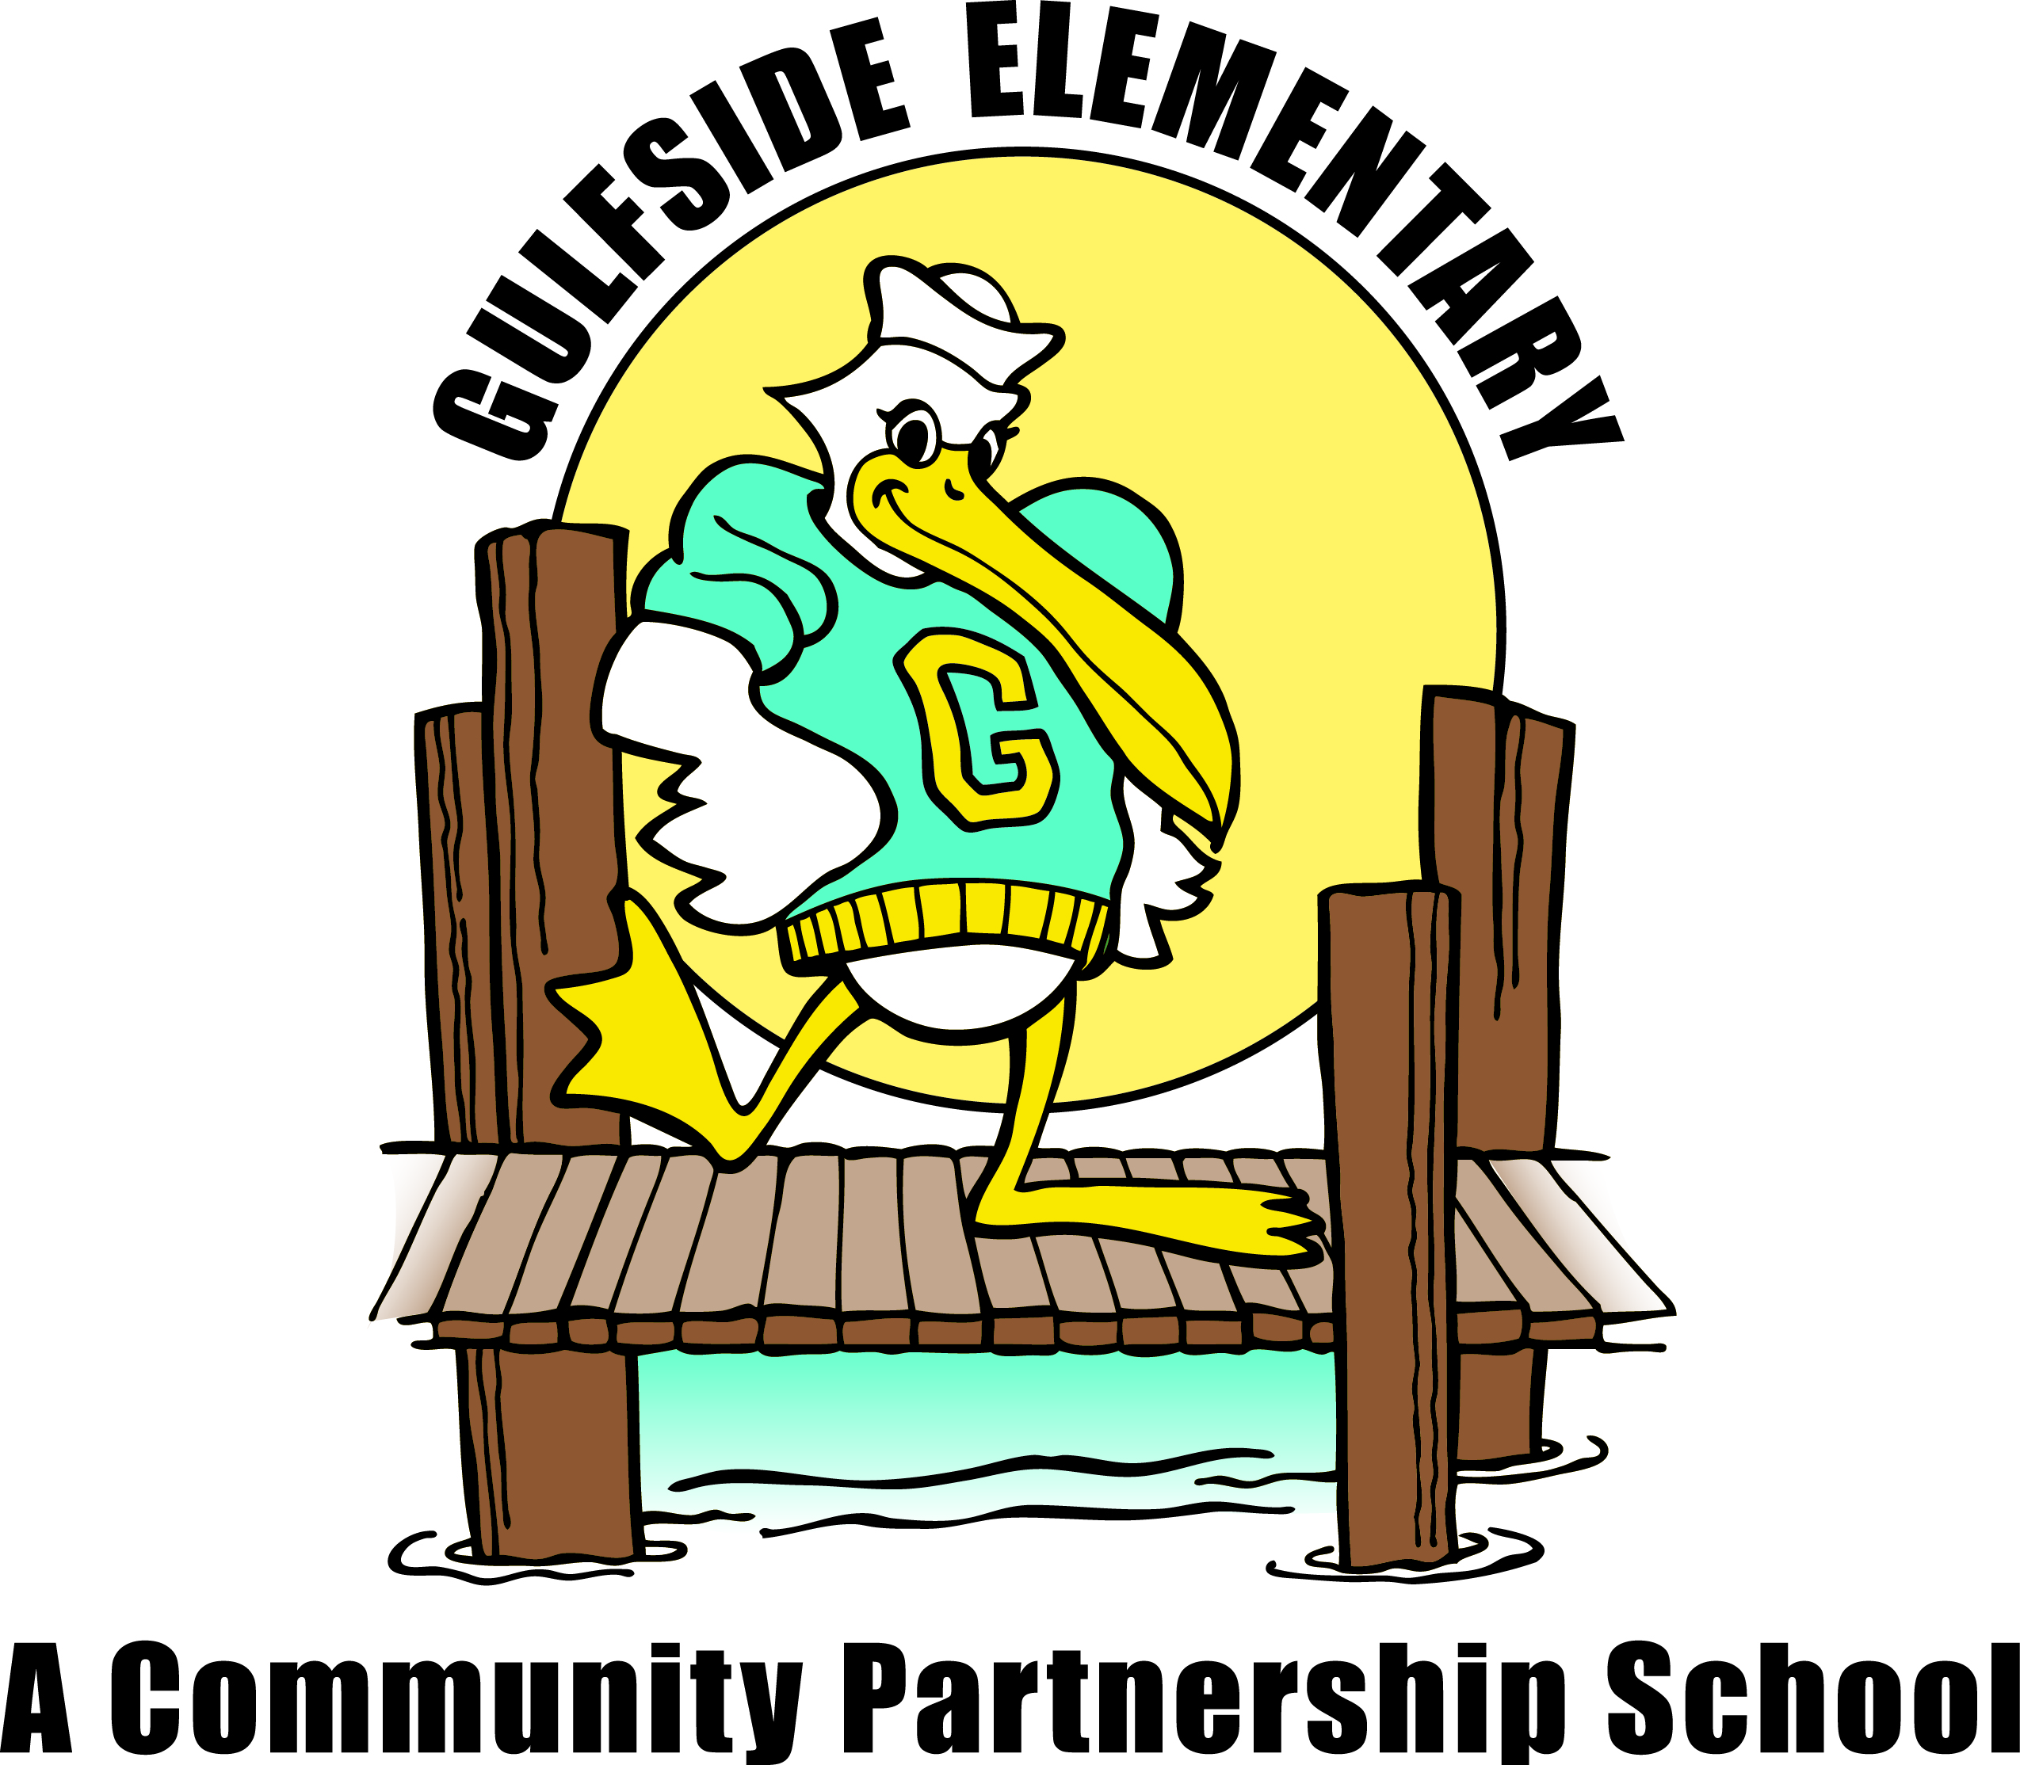
Pelican
Press

Jodi Legg, Asst. Principal
jlegg@pasco.k12.fl.us
Gulfside
Elementary

Clara Craig, Principal
ccraig@pasco.k12.fl.us
November 5, 2020 gses.pasco.k12.fl.us

Family Engagement
Families can partner with Gulfside by attending virtual and on campus school events, supporting classroom activities, becoming a Pelican Partner, joining PTO, SAC and Volunteering
Mark Your Calendar

November
11/3 Dental Services in our Community Hub
11/6 Breakfast and Lunch Pick-up 8-8:30am
11/9-11/20 Virtual School Book Fair
11/11 Veterans Day Virtual Celebration
11/12 Student Picture Make-Up Day
11/12 Cafeteria Turkey Dinner Day for Students/Staff
11/13 Breakfast and Lunch Pick-up 8-8:30am
11/13 Progress Reports
11/13 Traditional/MSOL Parent Decision Survey Due
(Please see link on our school web page: gses@pasco.k12.fl.us )
11/16 District Pasco Pathways Virtual Event
11/18 Great American Teach In-Virtual
11/18 Dental Services in our Community Hub
11/20 Breakfast and Lunch Pick-up 8-8:30am
11/23-27 Thanksgiving Break
11/30 Students and Staff Return to School

December
12/2 Dental Services in our Community Hub
12/4 Breakfast and Lunch Pick-up 8-8:30am
12/11 Breakfast and Lunch Pick-up 8-8:30am
12/18 Breakfast and Lunch Pick-up 8-8:30am
12/18 End of 2nd Quarter/1st Marking Period
12/21-1/4 Winter Break
1/5 Teacher Planning Day
1/6 Students Return

Every Monday and Wednesday
Hot Dinner pickup in the car loop (registration required- see link on GSES Hub Facebook page)
Food Box pick-up from 5:00 pm-5:30 pm at GSES, contact Mary Peralta at 727-774-6050.
Principal’s Message
Dear Gulfside Families,

As you know this year looks very different and our staff and I truly appreciate your support! As we continue our work for school safety and student achievement, we are planning ahead for Semester 2. We need all families to complete the parent survey for student learning preferences for Semester 2. The Survey will be posted on our school website with the following choices for Semester 2: Traditional Classroom, mySchool Online or Pasco eSchool. With the increasing number of students returning to campus, we are working to add or bring teachers back into classrooms to ensure continued student safety and learning, while still supporting our online learners. Please complete the survey by 11/13, and call me if you have any questions.

All students have the opportunity to excel at their own pace with their individual IRLA Reading Goals. Please ask your child what IRLA level they are reading at and what is their current reading goal. All students are also encouraged to take reading response quizzes online from school or at home. Please reach out to your child’s teacher for more information. Each month we will host a Reading Celebration for students who are actively reading and demonstrating good comprehension skills at their independent reading level. Please look for our Thanksgiving Break Student Reading Challenge soon!

We will have our Great American Teach In on 11/18, and we need guest speakers who will share with students about their job or a hobby. This year, due to COVID, all presentations need to be pre-recorded. Please contact Laura McClellan at 727-774-6000 for more information!

I am very thankful for all of our Gulfside families as we work together to make a positive difference in our community and for every child, every day!

Sincerely, Ms. Craig

Thank You to All of Our Veterans!
PBIS Corner: (Positive Behavior Intervention System)
Staff Shout Out
Has a staff member at Gulfside Elementary gone above and beyond for you, your child, or family? If so, please take a moment and tell us so we can recognize them for their dedication. You can send an email to Dawn Ballister @ dballist@pasco.k12.fl.us. We will share your moment with students, family and staff in the next newsletter.

FREE & REDUCED LUNCH APPLICATION
Please keep your Free and Reduced Lunch status up to date as all approvals are for one school year only. All families must apply now to guarantee continued benefits. Please visit https://connectplus.pasco.k12.fl.us/do/fns/?features=free-or-reduced-price-meal-application
and click on the Free and Reduced Lunch link.

-------------------------------------------------
Calling All Veterans!
We want to honor you! Please complete the Veterans Day Form located below or submit the electronic form on our school web page along with a photograph so we can honor our Veterans virtually this year. Photographs will be returned.
Thank you for your service to maintain safety and freedom for our country and community!

Student’s name:

_______________________________________
Military family/community member’s name:

_______________________________________
Branch of Military:

Rank:____________________________________

Total number of years of Service:

________________________________________

Please return this form along with a photograph to Ms. Craig at Gulfside Elementary School.

Gulfside Pelicans have three school-wide expectations that we adhere to on a daily basis. They are: Be Respectful, Be Responsible, and Be Safe. Each day, our students are reminded of these expectations by their teachers as well as by our visuals around campus. With these three expectations, our goal is for ALL students to be successful in their learning, as well as socially and emotionally safe. Along with our three big school-wide expectations, we also strive for Pelican Pride!
P- Pelicans are safe
R- Respectful and Responsible
I-Inspired to Learn
D- Driven to Succeed
E- Empowered to Lead
Please help us by reviewing these with your child(ren) and encouraging them to have Pelican ‘Pride’ at school every day!
October Citizens of the Month Congratulations: Chase Foltz, Raelyn Jimenez, Dylan Stephens, Sarahi Garcia Cruz, Michael Butler, Nicholas Major, Serenity Holbrook, Christopher Pacheco Lopez, David Vasquez, Sophia Johnston, Royce Martin, Joshua Peralta, Jordynn Burns, Azalea Turner, Aniya Farr, Kaden Cadrecha, Dashawn Booker, Jaydon Jose, Evan Inga, Zakari Joyner, Joshua Schneider, Joxiel Caballero, Aubree Meddaugh, Ziana Higgins, Andrew Garcia, Eduardo Caballero, Sophie Mechlinski, Kumony Howard, Marianna Earnest, Janiah White, Matthew Capabianco and Nayann Deen.
Great Job Pelicans!

FREE Breakfast and Lunch for All
Pasco school district is providing free breakfast and lunch for all on-campus students. Additionally, Pasco school district is serving a week’s worth of meals (breakfast and lunch) curbside to mySchool Online students, quarantined students, and children in the community 18 years and under. Meals are free and Gulfside pick up is each Friday morning from 8am to 8:30am in the bus loop. Please use this link http://www.pasco.k12.fl.us/fns/mform/view.php?id=269401, so we can be best prepared for pick up.

