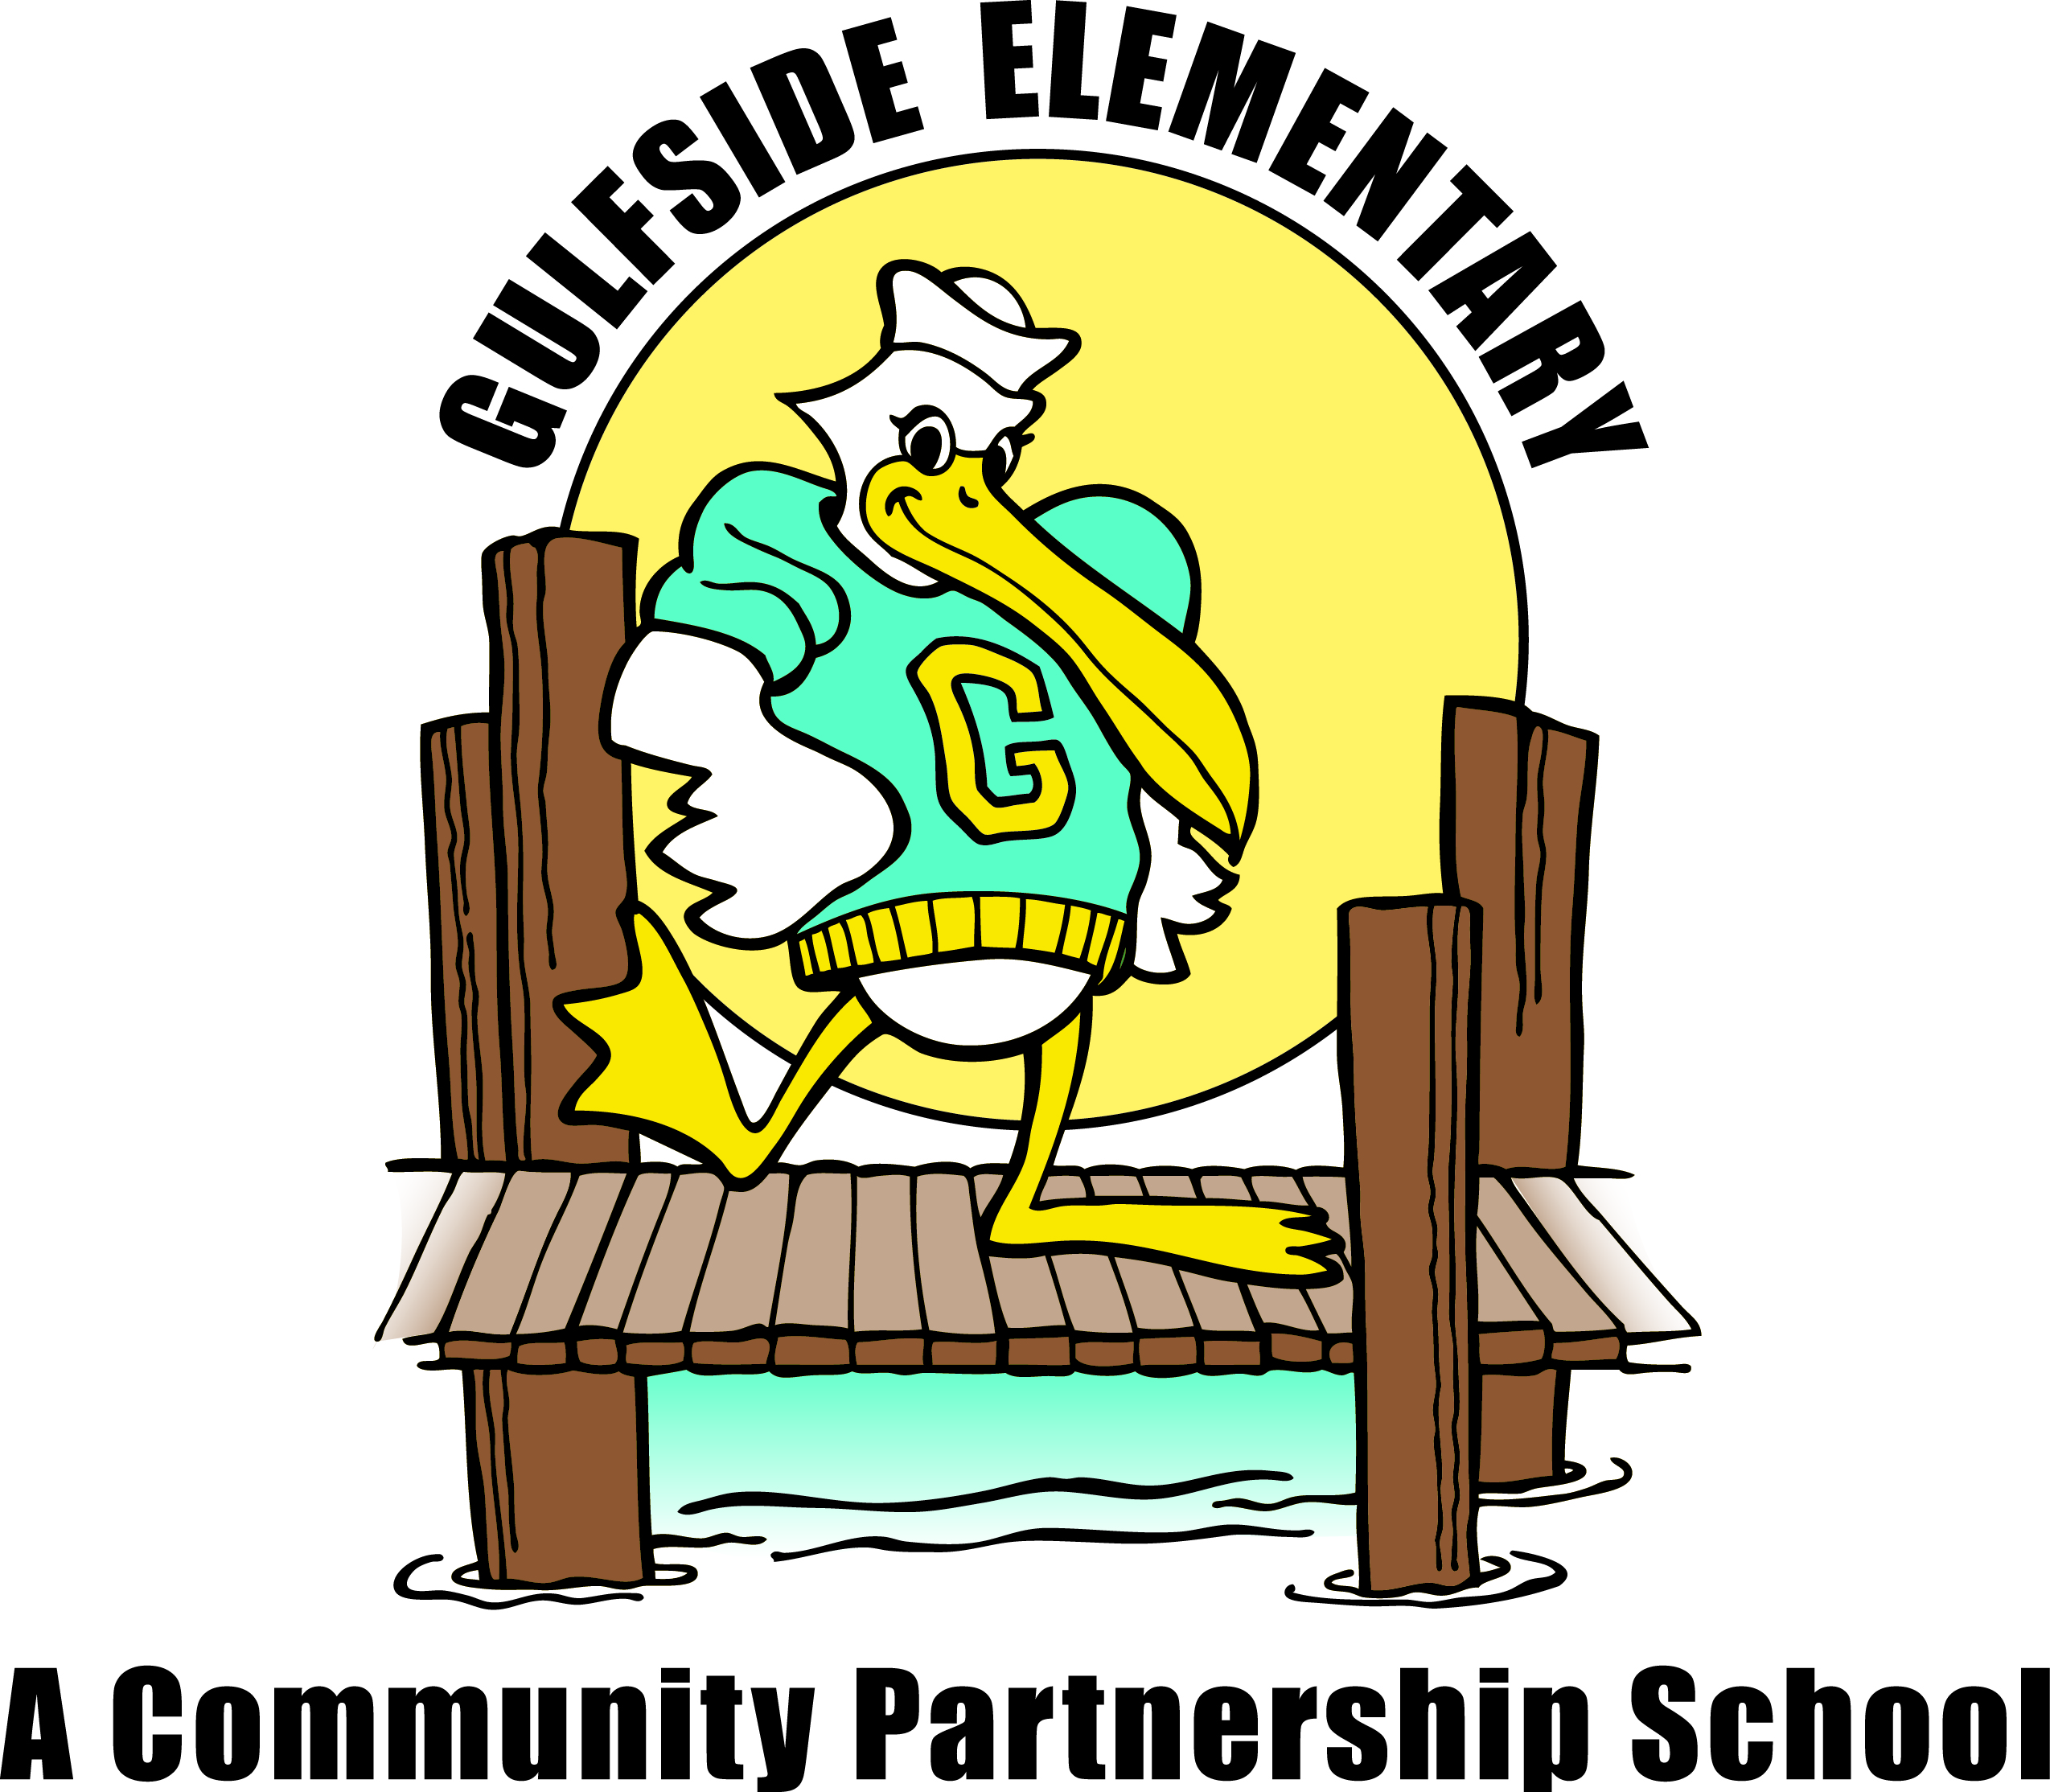
Pelican
Press

Jodi Legg, Asst. Principal
jlegg@pasco.k12.fl.us
Gulfside
Elementary

Clara Craig, Principal
ccraig@pasco.k12.fl.us
October 6, 2020 gses.pasco.k12.fl.us

Family Engagement
Families can partner with Gulfside by attending virtual and on campus school events, supporting classroom activities, becoming a Pelican Partner, joining PTO, SAC and Volunteering.
Mark Your Calendar

October

10/7 Dental Services Day
10/9 Breakfast and Lunch Pick-up 8-8:30am
10/16 End of 1st Quarter
10/16 Breakfast and Lunch Pick-up 8-8:30am
10/19 Teacher Planning Day: No School for Students
10/21 Dental Services Day
10/23 Breakfast and Lunch Pick-up 8-8:30am
10/27 Report Cards Posted in myStudent
10/27 Bahama Bucks Pelican Night
10/28 October Reading Celebration
10/28 Dental Services Day
10/28 CLC/SAC Meeting 2:00pm/2:30pm
10/30 Breakfast and Lunch Pick-up 8-8:30am
10/30 Good Character School Event

November

11/3 Dental Services Day
11/6 Breakfast and Lunch Pick-up 8-8:30am
11/11 Veteran’s Day
11/13 Breakfast and Lunch Pick-up 8-8:30am
11/13 Progress Reports
11/18 Dental Services Day
11/20 Breakfast and Lunch Pick-up 8-8:30am
11/23-27 Thanksgiving Break

Every Monday and Wednesday
Hot Dinner pick-up in the car loop (registration required -see link on GSES Hub Facebook page)
Food Box pick-up from 5:00pm-5:30pm at GSES, contact Mary Peralta at 727-774-6050.

Every Monday and Wednesday
Hot Dinner pickup in the car loop (registration required- see link on GSES Hub Facebook page)
Food Box pick-up from 5:00 pm-5:30 pm at GSES, contact Mary Peralta at 727-774-6050.
Principal’s Message
Dear Gulfside Families,
It is almost the end of Quarter 1! While our Open House this year looked very different, we hope you had the opportunity to engage with your child’s teacher. Please be sure to request a parent teacher conference and let the teacher know if you prefer to meet by zoom or in the building. All visitors on campus will be screened before entering your child’s classroom. Teachers and staff are required to engage in self-screening each day before reporting to work on campus.
Your children have been engaged both academically and socially in learning experiences based on grade level expectations. Arriving on time and staying engaged in the learning is the key to a successful school day both online and in the classroom.
One of our focus areas this year is to write across all curriculum areas. In Math students will explain their reasoning and problem solving steps, in Science students will engage in the scientific process and noting observations through writing, in Reading students will respond to the text using inferences and evidence from the text, and in Social Studies writing will be based on historical artifacts and events.
Thank you to all of our Gulfside families for the support, questions and encouragement you give to our Gulfside staff. We will always be here to support you because you make the biggest difference in your child’s achievement and well-being.

Sincerely, Ms. Craig

FREE & REDUCED LUNCH APPLICATION
Please keep your Free and Reduced Lunch status up to date as all approvals are for one school year only. All families must apply now to guarantee continued benefits. Please visit https://connectplus.pasco.k12.fl.us/do/fns/?features=free-or-reduced-price-meal-application
and click on the Free and Reduced Lunch link. The approvals for 2019-2020 school year will expire soon.

September Citizens of the Month Congratulations: Cheyenne See, Rylan Robinson, Emily Ferguson, Ariana Munitz, Jaxson Stone, Isabella Vazquez, Seth Gollihue, Jasser Diaz, Dixie Swan-Thurston, Evangely Acosta-Ramos, Valentino Dattalo, Allison Isham, Jeffrey Foltz, River Iverson, Wyatt Christian, Rylee Fryman, Kaylie Martin, Qiana Arlt, Danica Munitz, Yarineiely Alicea-Rodriguez, Roshondrick Mathieu, Isabella Hatcher-Miller, Chase Stone, JuMiya Howard, Martin Kharchuk, Adam New, Isabella Vazquez, Gaige Bell, Victoria Kazmierski, Avery Farr, Tristen Nelson-Wright. Great Job Pelicans!
Staff Shout Out
Has a staff member at Gulfside Elementary gone above and beyond for you, your child, or family? If so, please take a moment and tell us so we can recognize them for their dedication. You can send an email to Dawn Ballister @ dballist@pasco.k12.fl.us. We will share your moment with students, family and staff in the next newsletter.

One Team, One Mission,
One Community!

School Involvement Opportunities
If you would like to be more involved in your child’s school, please contact Mary Peralta at 727-774-6050.
SAC: We are looking for parent representatives to serve on our School Advisory Council. We need your input and ideas in all the work we are doing, and our meetings will be virtual by Zoom for this Semester.
PTO: Parent involvement is key in our PTO this year as we get creative to plan events for our school community that are both safe and fun for the whole family! PTO fundraisers such as an online Penguin Holiday Shop and Smencil sales help support our students and school community.
VOLUNTEER: Please let us know if you are interested in volunteering this year on our school campus or from home. We have many opportunities!

FREE Breakfast and Lunch for All
Pasco school district is providing free breakfast and lunch for all on-campus students. Additionally, Pasco school district is serving a week’s worth of meals (breakfast and lunch) curbside to mySchool Online students, quarantined students, and children in the community 18 years and under. Meals are free and Gulfside pick up is each Friday morning from 8am to 8:30am in the bus loop.
We encourage families intending to participate curbside to complete the Meal Reservation Form, http://www.pasco.k12.fl.us/fns/mform/view.php?id=269401, so we can be best prepared for curbside participation.

