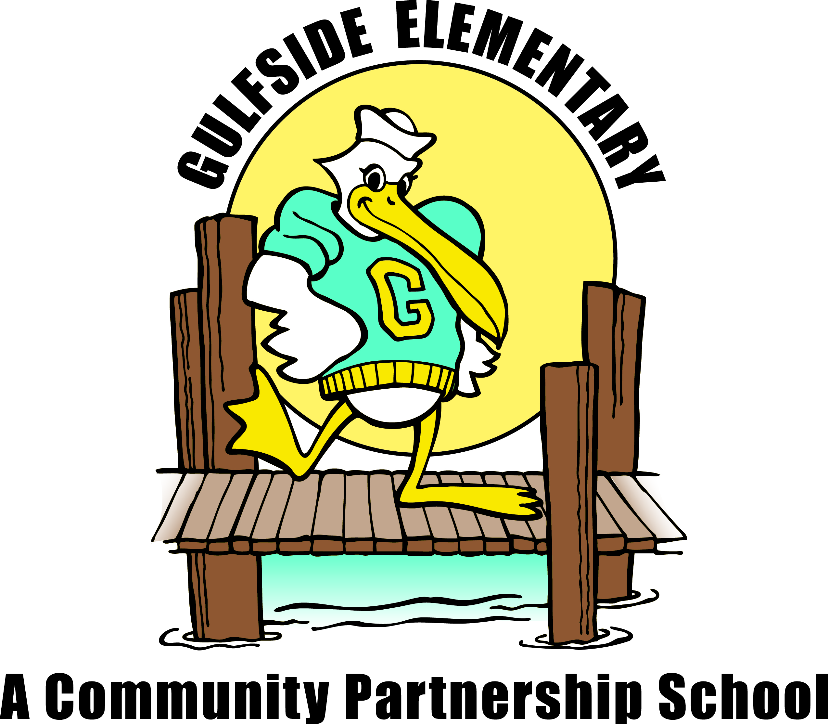
Pelican
Press

Jodi Legg, Asst. Principal
jlegg@pasco.k12.fl.us

Clara Craig, Principal
ccraig@pasco.k12.fl.us
September 10, 2019 gses.pasco.k12.fl.us

Gulfside
Elementary

Family Engagement
Families can partner with Gulfside by attending school events, supporting classroom activities,
becoming a Pelican Partner, joining PTO and Volunteering!
Mark Your Calendar
September
9/11 Early Release Day 1:50PM
9/13 Astro Skate 4:00 – 6:00pm
9/13 Progress Reports available online
9/19 SAC Meeting 8:00am
9/20 Dental Service Day

October
10/4 Citizen of the Month 8:45am
10/9 Early Release Day 1:50PM
10/11 Astro Skate 4:00-6:00pm
10/14 No School for Students
10/17 SAC Meeting 8:00am
10/17 Student Picture Retakes
10/22 Report Cards available online
10/25 Trunk or Treat 4:45 – 6:45pm
10/31 GSES Good Character Parade 10-10:30am

November
11/1 Citizen of the Month 8:45am
11/8 Health Screening
K to 3rd Grade & new to FL
11/11 Veteran’s Day Celebration 2:30pm
11/13 Early Release Day 1:50PM
11/15 Progress Reports available online
11/20 Great American Teach-In
11/21 SAC Meeting 8:00am
11/25 to 11/29 Thanksgiving Break

Every Wednesday - One Community Now Dinner 5:30pm GSES Cafeteria

Principal’s Message
Welcome Back Pelican Families!
It has been a wonderful start of the new school year with our students learning and practicing procedures, routines and expectations in their new classrooms. Please be sure to ask your child what their IRLA Reading Level is. Students will continue to earn spirit sticks as they progress to each new IRLA level. If your child is new to Gulfside, they will earn a spirit stick keychain when they demonstrate the reading ready position during IRLA silent reading time.
It’s a new school year, so please be sure to visit our school website to apply to become a school volunteer. We always need volunteers to help in the Media Center, Community School Hub, Cafeteria and other areas in our school! Thank you to all of our families who joined the PTO this year! I look forward to a great year of PTO activities for our school, and we appreciate your support. Please be sure to check the important dates listed in this newsletter, and on our school website http://gses.pasco.k12.fl.us/
Thank you to everyone that came out to our Open House! Please contact us at 727-774-6000 if you have any questions, suggestions or concerns. On behalf of our entire school community, thank you for all you do every day for your child/children, and we are looking forward to an amazing 2019-20 school year!

Sincerely,
Ms. Craig

Photos & School Videos
If for any reason, you do not want your child photographed or in school videos please come to the front office to request a Media Release Non—Consent Form.
Attendance Matters
Sept is Attendance Awareness Month! With the school year underway, it’s important that students be in class every day ready to learn.
This year we are going to have an attendance competition between the grade levels. The class with the best attendance within the grade level will earn a special celebration throughout the school year! For more information please Holly Hintz, School Social Worker at 727-774-6075.

FREE & REDUCED LUNCH
Free and Reduced Lunch approvals are for one school year. All families must apply now to guarantee continued benefits. Please visit www.pasco.k12.fl.us, click Parent Link on the top of the page, then go to General Information and click on the Free and Reduced Lunch link. The approvals for 2018-2019 school year will expire soon. All students are offered a free breakfast beginning at 9:20AM each day – No application needed for breakfast.

Lunch Times
Kindergarten | 12:35 pm – 1:05 pm
1st Grade | 12:05 pm – 12:35 pm
2nd Grade | 12:55 pm – 1:25 pm
3rd Grade | 11:00 am – 11:30 am
4th Grade | 11:15 am – 11:45 am
5th Grade | 11:35 am – 12:05 pm

Visitor/Volunteer What is the difference?
Visitors and Volunteers must go directly to the front office to sign-in and pick-up their Raptor badge. All non-employee adults on campus must wear their identification badge during their visit.

Visitors are individuals who may be on campus. Most often, a visitor is a family member coming for lunch with their child, parent conference, or attending a meeting on campus. Visitors are not permitted to have contact with other students, besides their own child.

Volunteers must be approved through the District Office to work on campus under the direction of a staff member. To register to become a volunteer please visit www.pasco.k12.fl.us, under Helpful Links – Volunteer Application. Mary Peralta 727-774-6050, after you receive your submission confirmation.

We welcome volunteers any day. You can help stamp and organize books in the Media, read with students, be extra eyes and hands in the cafeteria, help with classroom projects, make copies and help with our daily routines. Volunteer times can be as little as an hour to a full day. We appreciate all of our wonderful volunteers!!!

Parent Right to Know
Staff Shout Out
Has a staff member at Gulfside Elementary gone above and beyond for you, your child, or family? If so, please take a moment and tell us so we can recognized them for their dedication. You can send an email to Dawn Ballister @ dballist@pasco.k12.fl.us. We will share your moment with students, family and staff in the next newsletter.

You have the right to know the professional qualifications of the educators who instruct your child. Federal law allows you to obtain certain information in a timely manner about your child’s classroom teachers and instructional assistants/paraprofessionals. You have the right to ask for the following information about each of our child’s teachers and instructional assistants/paraprofessionals:

- The teacher’s Florida certification area(s) and,
  - if the teacher is teaching infield, or
  - if the teacher is qualified infield according to the District School Board of Pasco County.
- The teacher’s college degree(s) and areas of study.
- The teacher’s advanced college degree(s) and areas of study.
- The qualifications of any instructional assistant/paraprofessionals who provide services to your child.

In addition, you have the right to be provided information on your student’s level of achievement on assessments in reading/language arts, mathematics and science. Please contact your teacher.

One Team, One Mission,
One Community!

