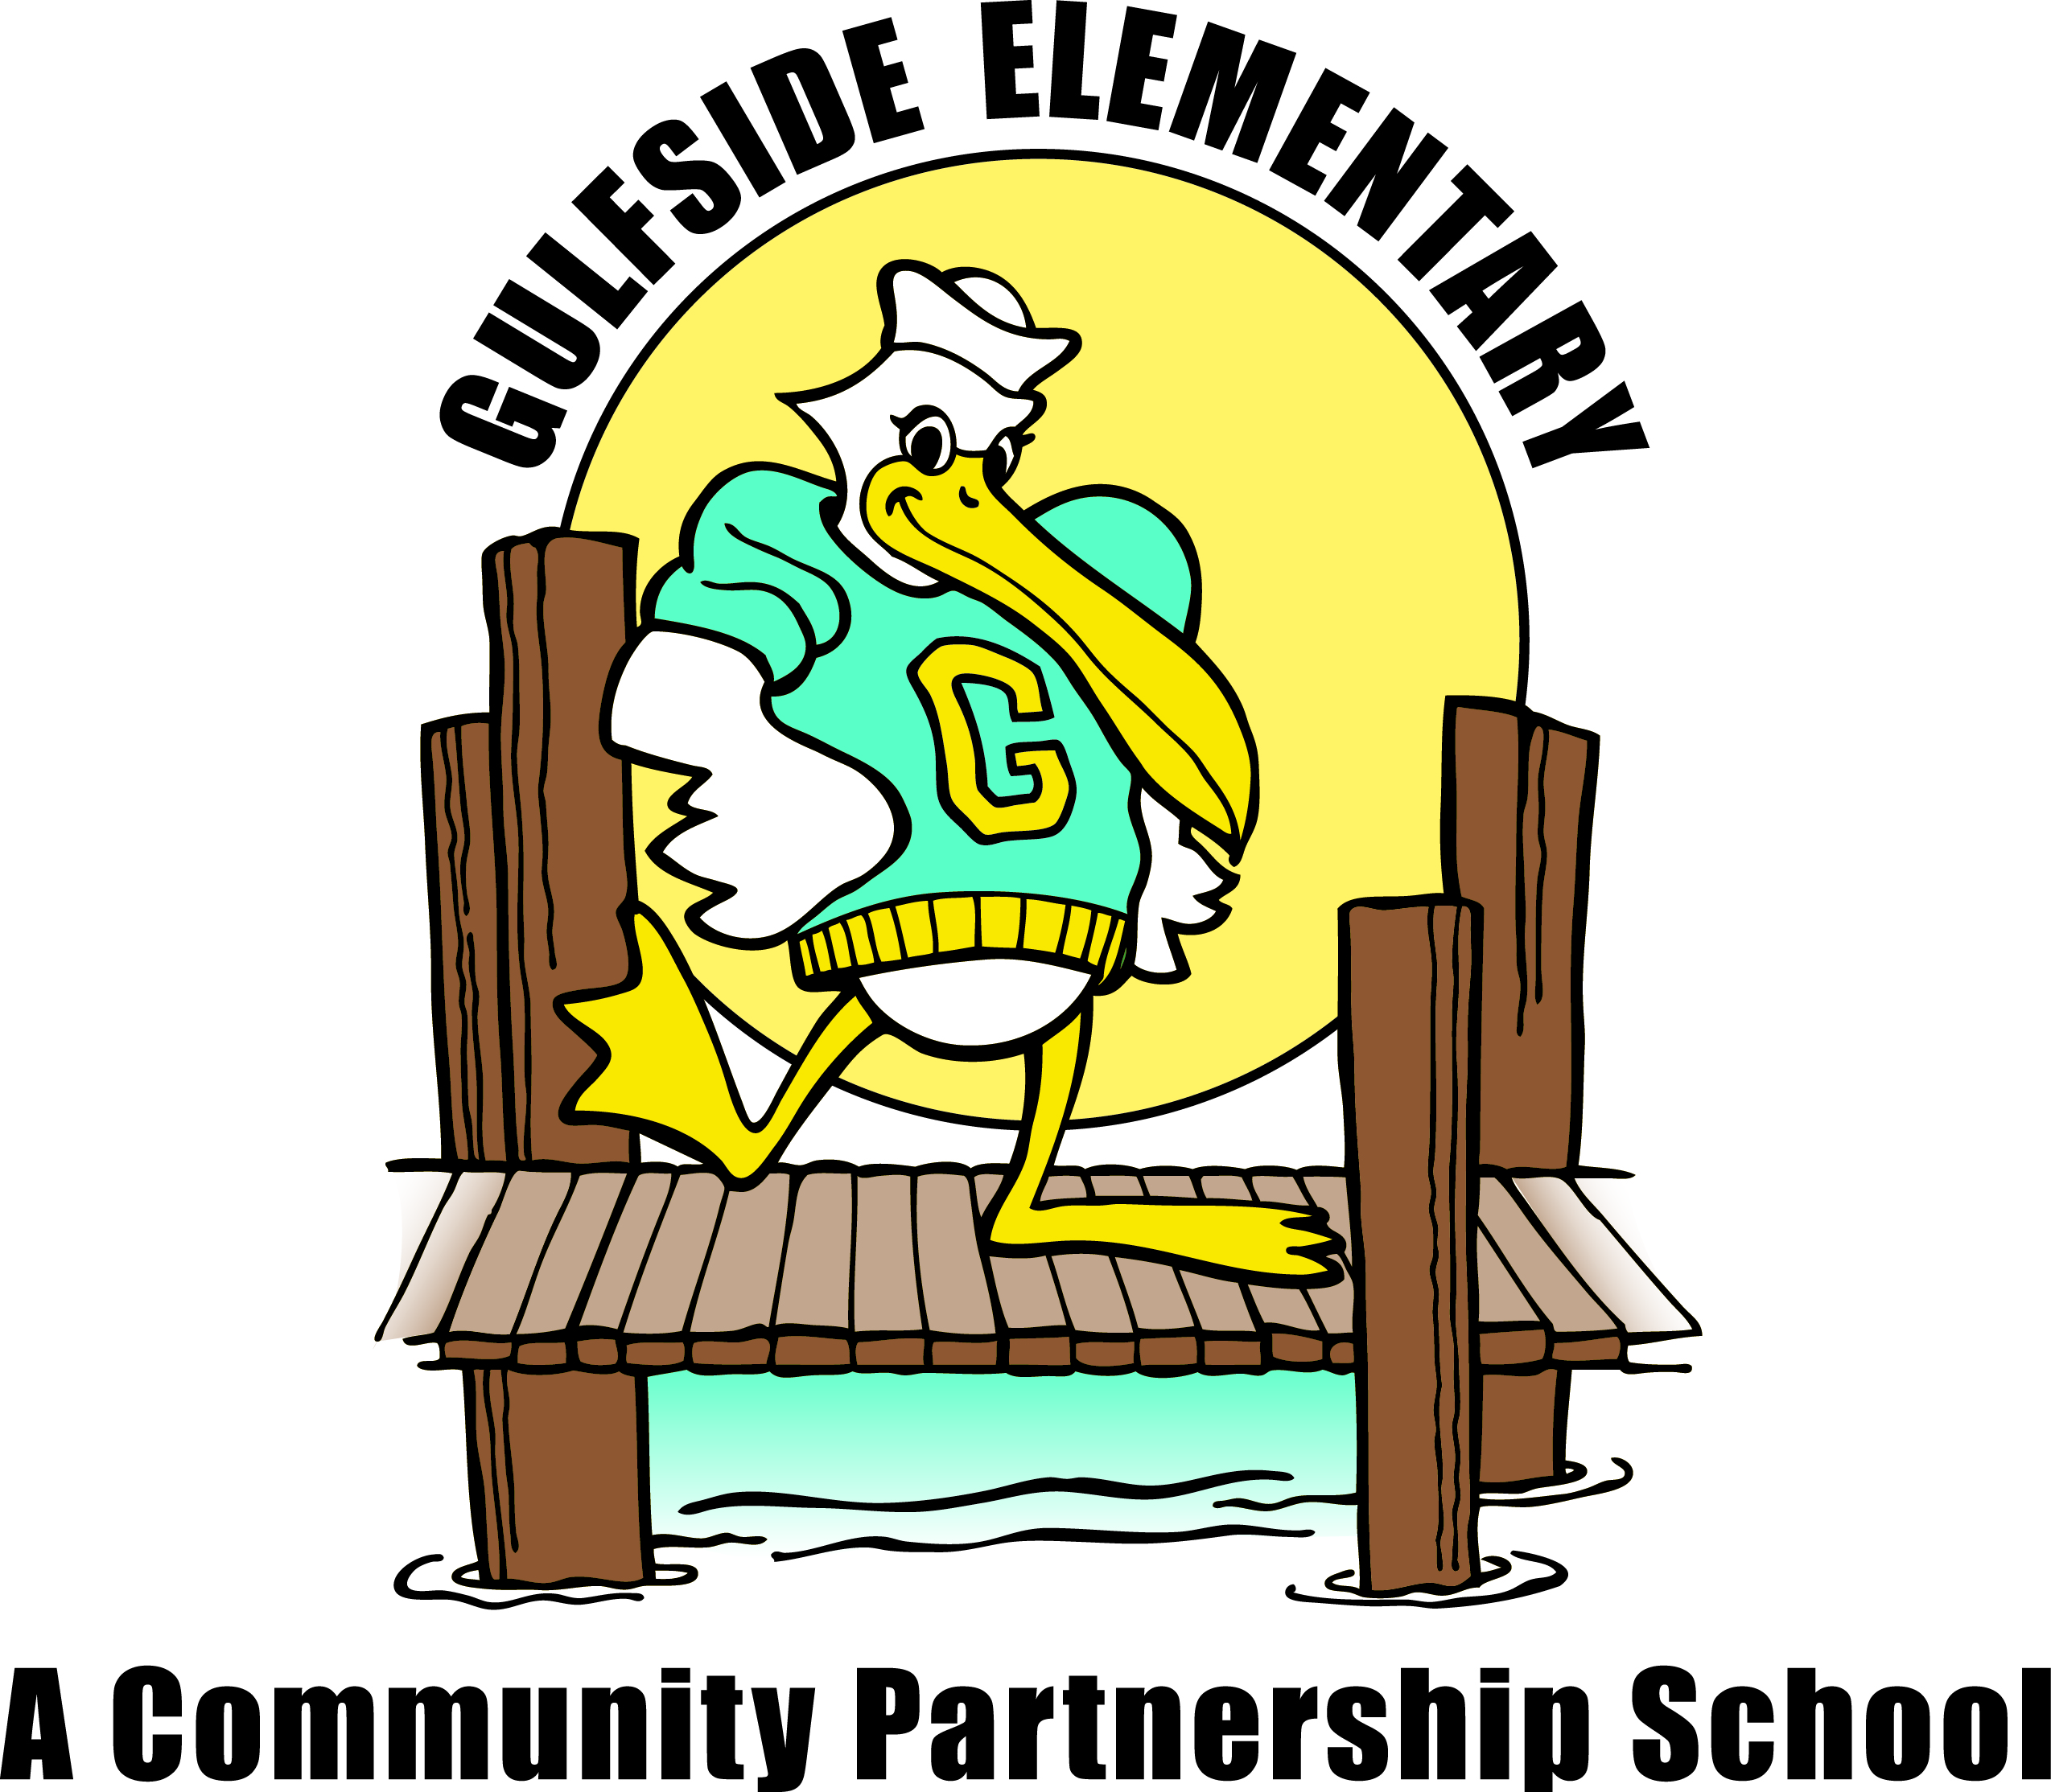
Pelican
Press

Jodi Legg, Asst. Principal
jlegg@pasco.k12.fl.us
October 8, 2019 gses.pasco.k12.fl.us

Gulfside
Elementary

Clara Craig, Principal
ccraig@pasco.k12.fl.us

Family Engagement
Families can partner with Gulfside by attending school events, supporting classroom activities,
becoming a Pelican Partner, joining PTO and Volunteering!

Mark Your Calendar
October

10/9 Early Release Day 1:50PM
10/11 Astro Skate 4:00-6:00pm
10/14 No School for Students
10/17 SAC Meeting 8:00am
10/17 Student Picture Retakes
10/22 Report Cards available online
10/23 Trunk or Treat 5:00 – 7:00pm
10/31 GSES Good Character Parade 10-10:30am

November

11/1 Citizen of the Month 8:45am
11/11 Veteran’s Day Celebration 2:30pm
11/13 Early Release Day 1:50PM
11/15 Progress Reports available online
11/20 Great American Teach-In
11/21 SAC Meeting 8:00am
11/25 to 11/29 Thanksgiving Break

December

12/6 Citizen of the Month 8:45am
12/7 Astro Skate 4:00-6:00pm
12/12 Dental Services Day
12/12 PTO Meeting 4:00pm
12/20 SAC Meeting 8:00am
12/21 End of 2nd Quarter
12/24 to 1/4/20 Winter Break

Every Wednesday - One Community Now Dinner 5:30pm GSES Cafeteria

Principal’s Message

Dear Gulfside Families,

Happy Fall! The month of October brings many opportunities for fun family involvement. Please join us for the Fall Festival/Trunk or Treat Event on October 23rd. Dinner will be free and provided by One Community Now. At this event, families can enjoy games and snacks by purchasing tickets, and also engage in fun in a free Trunk or Treat area. On October 31st, families are invited to watch our Student “Good Character” costume parade starting at 10am at the bus loop.

I want to encourage all of our students to read every night! The goal should be to read a book they enjoy for at least 15 minutes, and in order to build “reading stamina”, try to work up to reading for at least 25-30 minutes each night. After reading, talk with your child about what they read, and have them respond to their reading by writing or drawing in their reading log or journal.

Together, we will make this a great month of learning! Please contact your child’s teacher if you would like a conference to discuss your child’s progress. Go Pelicans!
Sincerely,
Ms. Craig

Student Picture Re-take Day
Picture re-take day is Friday, October 19th. Students who would like a re-take of their fall picture free of charge must return the original package. Also, all students new to our school after September 6^{h} will have their picture taken. Picture packets are available in the front office. Please contact Dawn Ballister if you have any questions.

Volunteer Opportunity
Do you love reading and want to inspire young students to read? Team Gulfside is looking for community volunteers to help students reach their literacy goals. There are many different ways you can help.
- Create literacy games for students.
- Volunteer your time to read with students.
- Help clean and organize our reading resources and science resources.
- Create instructional based bulletin boards that celebrate student achievements.
How can you get started? Call Mary Peralta at 727-774-6050 for more information or to get information on how to become a registered volunteer. Thanks for taking the first step in supporting literacy in your community.

Our Community School is asking for help organizing the food pantry, clothing closet and school supplies. If you are available during the school day, please call Mary Peralta at 727-774-6050.

Lost & Found
We have lunchboxes and jackets in the cafeteria lost and found area. Please encourage your child to check for any lost items when they go into the cafeteria. One way to make sure your child’s lost items are returned is to use a black sharpie marker to put their name on their personal belongs.

YMCA at Gulfside
Cultivating 21st century learners is an ever-growing challenge in today’s school system. It is statistically proven that a child today needs additional opportunities outside of the classroom to deal with real – life problem solving skills. By sending your child to the Y each day you are helping them interact with materials to build cultural sensitivity, foster 21st century skills, discuss healthy life choices, and interact with math and literacy to build a better learner. Please contact Brie Thompson at 727-774-6092!

Big Brother/ Big Sisters
Make a difference by becoming a mentor to a child! It only takes one hour a week during the school day to invest in this program. If you would like to learn more about the program please contact Dawn Ballister.

Communication is Key
Ongoing and reciprocal communication between home and school is vital to ensure your child’s success. Ways to stay connected:
- Provide updated contact information to the front office in a timely manner.
- Visit the school webpage and Facebook for upcoming events and announcements.
- Request regular parent/teacher conferences
- Communicate with teachers via email (teacher’s email addresses are available on the school webpage).
- Read the Pelican Monthly Newsletter
Review Parent Information, the student handbook and student code of conduct online at http://www.pasco.k12.fl.us/parents
- Look for notes or comments in your child’s school planner.
- Listen to the School Connect telephone message on Sunday evening.
- Request language translators to assist if needed.

Out-of-Field Teaching Assignments
Individuals who are teaching out-of-field are certified in at least one area and are qualified to teach but are required to take additional course work or testing to add a coverage/endorsement to their certificate. The state also requires a teacher to take coursework/inservice towards an English for Speakers of Other Languages (ESOL) endorsement, when the teacher is the primary language arts provider and/or reading teacher for an ESOL student.

The following teachers have agreed to teach out-of-field while completing course work/testing: Celia LaCroix, Laurice Elkomos and Cara McGrath.

The following teachers have agreed to work towards the ESOL endorsement: Celia LaCroix and Cara McGrath.

